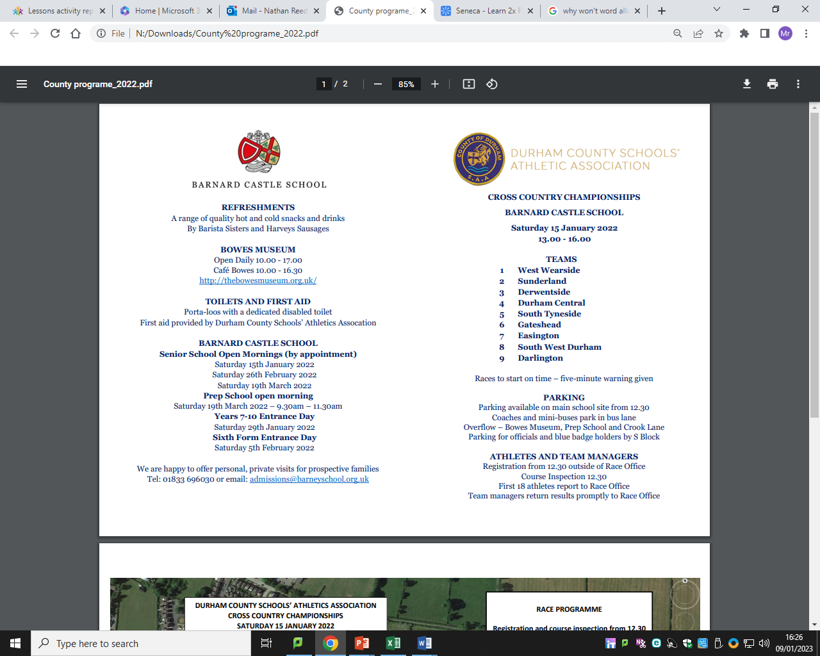

**TOILETS AND FIRST AID**

All toilets including a dedicated disabled toilet are found within the Sports Pavilion at Farringdon Community Academy.

First aid provided by Durham County Schools’ Athletics Association.

*Durham County Schools Athletic Association hosts the*

*Northern Inter County Cross Country Championships*

*Sunderland*

*Saturday 4th February*

*12.30pm – 3pm*

We would like to thank the following people without whom this event would not be able to take place.

* All officials and marshals on the course.
* Farringdon Community Academy for the use of their facilities.
* All County team managers and teachers for giving up their time to assist their county teams.
* All parents and spectators cheering on the athletes today.

**Counties**

Cleveland: 1 - 20

Cumbria: 21 - 40

Durham: 41 - 60

Northumberland: 61 - 80

North Yorkshire: 81 - 100

All races will use starting pens, athletes must ensure they are in the designated pen for their county. This changes depending on the race. Pen numbers are listed below.

**Parking & Refreshments**

Limited parking and reserved parking for officials and blue badge holders at Farringdon Community Academy (SR3 3EL)

Overflow parking –Silksworth Sports Complex (SR3 1PD)

Refreshments including hot food can be purchased from a mobile catering van within the Farringdon Community Academy grounds, located near the sports pavilion.

**ALL LITTER MUST BE PLACED IN BINS PROVIDED**

**Starting Pens (Y7’s)**

1. Cleveland
2. Cumbria
3. Durham
4. Northumberland
5. North Yorkshire

**Starting Pens (Juniors)**

1. North Yorkshire
2. Cleveland
3. Cumbria
4. Durham
5. Northumberland

**Starting Pens (Seniors)**

1. Durham
2. Northumberland
3. North Yorkshire
4. Cleveland
5. Cumbria

**Starting Pens (Inters)**

1. Northumberland
2. North Yorkshire
3. Cleveland
4. Cumbria
5. Durham

**ATHLETES AND TEAM MANAGERS**

Registration and course open from 11.30am.

Durham County athletes to register and collect Hoodies/Sweatshirts from the main school hall at Farringdon Community Academy.

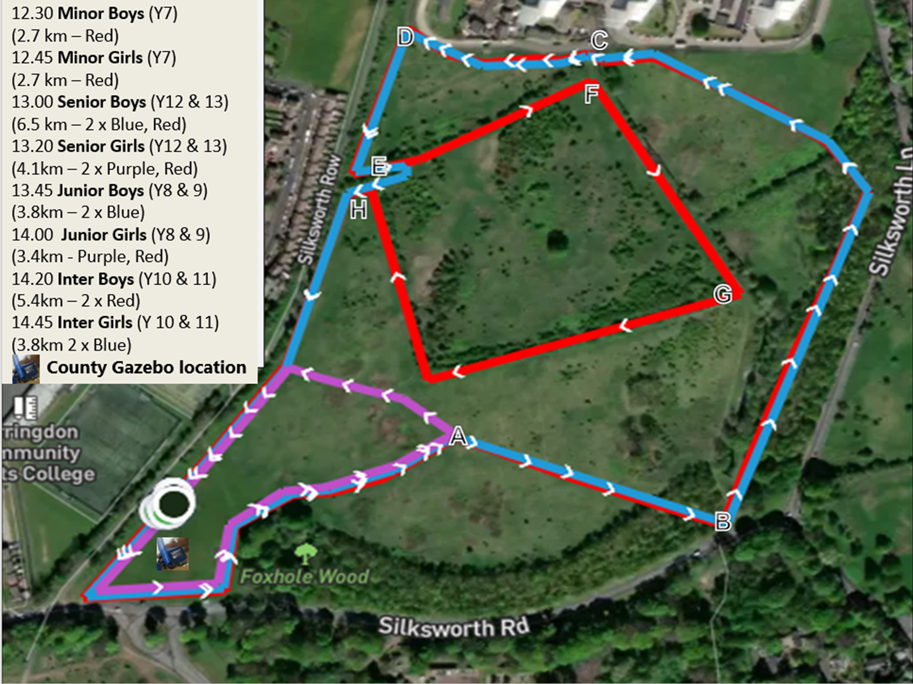

**Inter County Schools Cross Country Championships 2023**