Northumberland Schools’ Athletic Association
ESAA XC Cup 11am / Primary School Team Championships 1pm - Gateshead International Stadium – Tuesday 4 October 2016
Course Routes
ESAA Cross Country Cup, Round 1 | NSAA School Team Championships
JG - 11am – 2000m - Start-A-X-B-C-D-A-E-A-Finish (1 full loop + 1 small loop) | Y7/Y8 GIRLS – 12.30pm – 2000m - Start-A-X-B-C-D-A-E-A-Finish (1 loop + 1 small loop)
JB - 11.20am – 3000m – Start-A-X-B-C-D-A-E-A-X-B-C-D-A-Finish (2 full loops) | Y7/Y8 BOYS –12.45pm– 2000m - Start-A-X-B-C-D-A-E-A-X-B-D-A-Finish (1 loop & med loop)
IG - 11.40am – 3000m – Start-A-X-B-C-D-A-E-A-X-B-C-D-A-Finish (2 full loops) | Y3 & Y4 Races – from 1.00pm- 1050m – Start -A-X-B-D-A- Finish (1 medium loop)
IB – 12noon – 4500m - Start-A-X-B-C-D-A- E ….x3 (3 full loops) | Y5 & Y6 Races – from 1.40pm – 1550m – Start -A-X-B-C-D-A- Finish (1 full loop)
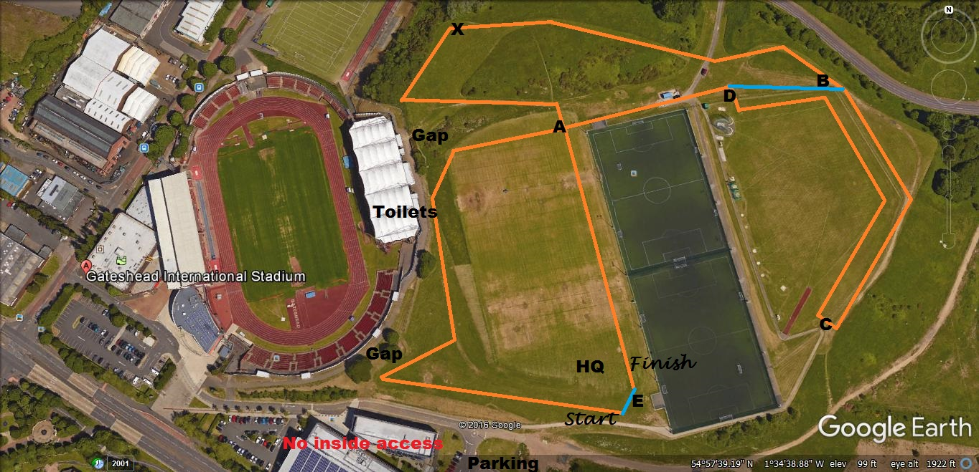
Emergency Contacts: Paul Ponton (Event Organiser) – 07747 791 732 / Kevin Flannery (Course Control) – 07443 453 169 / Steve John (HQ - Event Control – 00000 000 000)
googleearth/screenprint/paint/paulponton

