Northumberland Schools’ Athletic Association
ESAA XC Cup 11am / Primary School Team & Year 7 Championships 1pm - Gateshead International Stadium – Tuesday 2 October 2018
Course Routes
ESAA Cross Country Cup, Round 1 | NSAA School Team Championships
JG – 11.00am - 2000m - Start-A-B-C-D-E-F-A-X-A-Finish (1 full loop + 1 small) | Y7 GIRLS – 12.30pm – 2000m - Start-A-B-C-D-E-F-A-X-A-Finish (1 full loop + 1 small)
JB - 11.20am – 3000m – Start-A-B-C-D-E-F-A-X ….x2 (2 full loops) | Y7 BOYS – 12.45pm – 3000m - Start-A-B-C-D-E-F-A-X ….x2 (2 full loops)
IG - 11.40am – 3000m – Start-A-B-C-D-E-F-A-X ….x2 (2 full loops) | Y3 & Y4 Races – from 1.00pm- 1300m – Start -A-B-C-F-E-G-F-A- Finish
IB – 12noon – 4500m - Start- A-B-C-D-E-F-A-X ….x3 (3 full loops) | Y5 & Y6 Races – from 1.40pm – 1550m – Start -A-B-C-D-E-F-A- Finish (1 full loop)
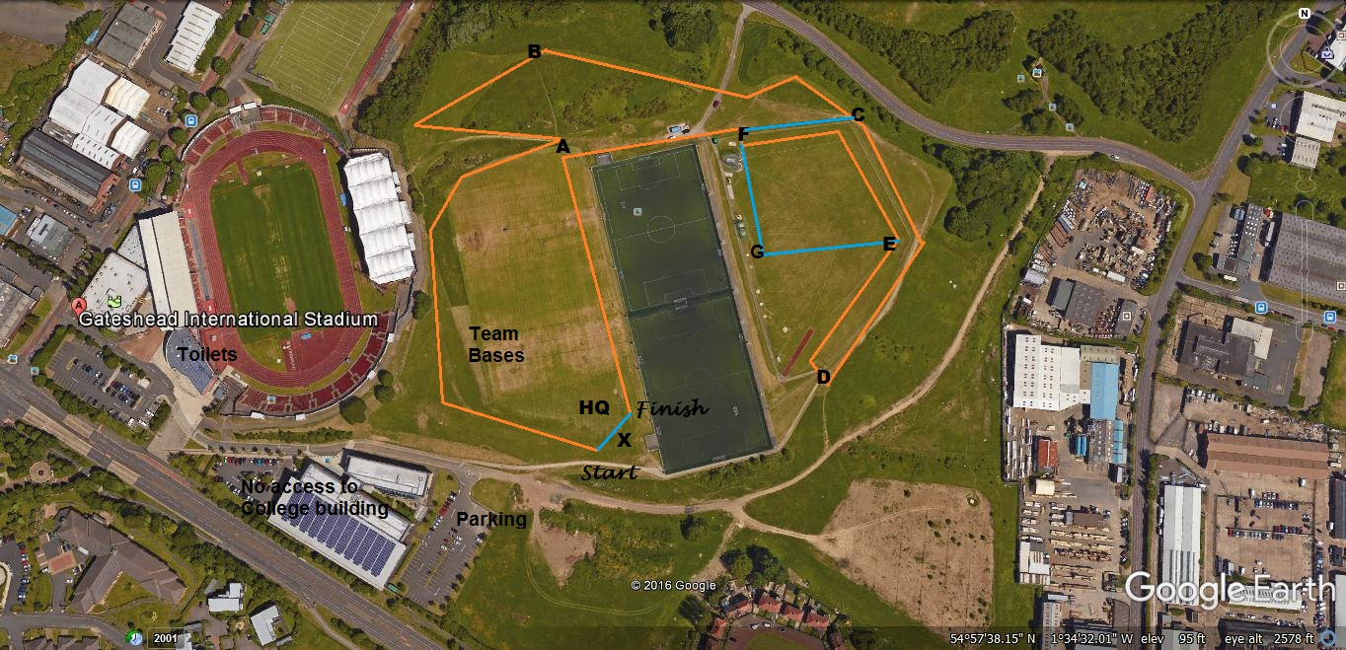
Emergency Contacts: Paul Ponton (Event Organiser) – 07747 791 732 / Kevin Flannery (Course Control) – 07443 453 169 / Steve John (HQ - Event Control – 07880 700 411)
googleearth/screenprint/paint/paulponton

